Topics: Binary tree traversals- inorder, preorder, post order, level wise -depth first and breadth first.
Id
Question | One can determine whether a Binary tree is a Binary Search Tree by traversing it in ____.
A | Preorder
B | Inorder
C | Postorder
D | None of the above
Answer | B
Marks | 1
Unit | 1

Id
Question | A binary tree can be converted in to its mirror image by traversing it in
A | Inorder
B | Preorder
C | Postorder
D | Anyorder
Answer | B
Marks | 1
Unit | 1

Id
Question | What is common in three different types of traversals (Inorder, Preorder and Postorder)?
A | Root is visited before right subtree
B | Left subtree is always visited before right subtree
C | Root is visited after left subtree
D | All of the above
Answer | B
Marks | 1
Unit | 1

Id
Question | The inorder and preorder traversal of a binary tree are d b e a f c g and a b d e c f g, respectively. The postorder traversal of the binary tree is:
A | d e b f g c a
B | e d b g f c a
C | e d b f g c a
D | d e f g b c a
Answer | A
Marks | 1
Unit | 1

Id
Question | Which of the following pairs of traversals is not sufficient to build a binary tree from the given traversals?
A | Preorder and Inorder
B | Preorder and Postorder
C | Inorder and Postorder
D | None of the Above
Answer | B
Marks | 1
Unit | 1

Id
Question | Which traversal of tree resembles the breadth first search of the graph?
A | Preorder
B | inorder
C | Postorder
D | Level order
Answer | D
Marks | 1
Unit | 1

Id
Question | Which of the following tree traversal uses a queue data structure?
A | Preorder
B | inorder
C | Postorder
D | Level order
Answer | D
Marks | 1
Unit | 1

Id
Question | Which of the following cannot generate the full binary tree?
A | Preorder and Inorder
B | Preorder and Postorder
C | Inorder and Postorder
D | None of the Above
Answer | D
Marks | 1
Unit | 1

Id
Question | Consider the following rooted tree with the vertex P labeled as root:  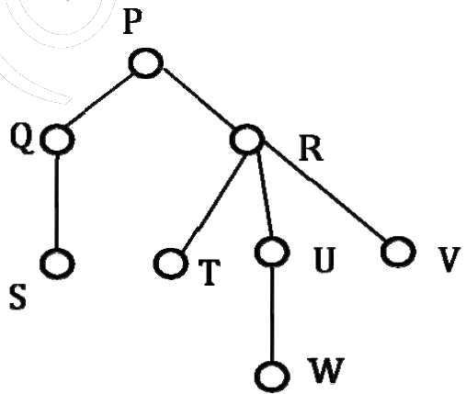  The in-order traversal is:
A | SQPTRWUV
B | SQPTURWV
C | SQPTWUVR
D | SQPTRUWV
Answer | A
Marks | 1
Unit | 1

Id
Question | Level order traversal of a rooted tree can be done by starting from the root and performing
A | preorder traversal
B | inorder traversal
C | depth first search
D | breadth first search
Answer | D
Marks | 1
Unit | 1

Id
Question | The following three are known to be the preorder, inorder and postorder sequences of a binary tree. But it is not known which is which.  MBCAFHPYK  KAMCBYPFH  MABCKYFPH  Pick the true statement from the following.
A | I and II are preorder and inorder sequences, respectively
B | I and III are preorder and postorder sequences, respectively
C | II is the inorder sequence, but nothing more can be said about the other two sequences
D | II and III are the preorder and inorder sequences, respectively
Answer | D
Marks | 1
Unit | 1

Id
Question | Consider the following sequence of nodes for the undirected graph given below.  a b e f d g c  a b e f c g d  a d g e b c f  a d b c g e f  A Depth First Search (DFS) is started at node a. The nodes are listed in the order they are first visited. Which all of the above is (are) possible output(s)?  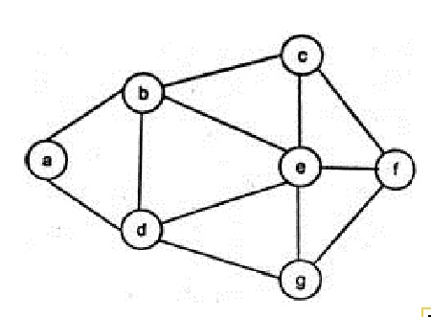
A | 1 & 3 only
B | 2 & 3 only
C | 2, 3 & 4 only
D | 1, 2 & 3 only
Answer | B
Marks | 1
Unit | 1

